1. Update the damage amount to 25000 for the car with a specific reg-num(example &#39;K

A053408&#39;) for which the accident report number was 12.

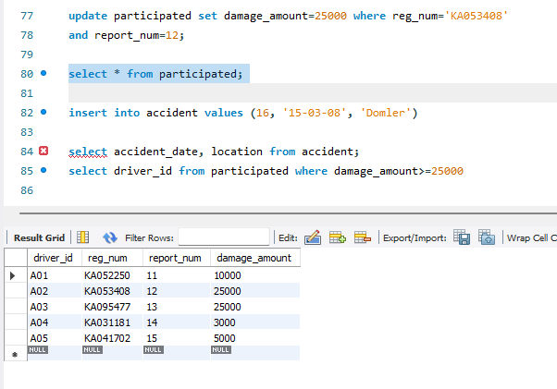

2. Add a new accident to the database.

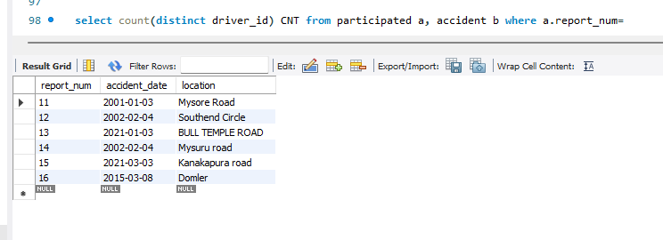

3. display accident_date and location from accident table.

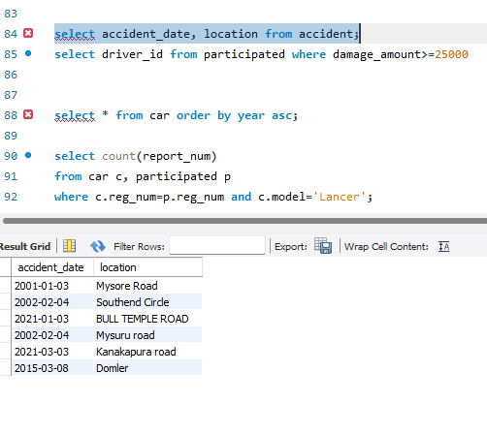

4. Display the driver_id who did the accident damage greater than or equal to Rs.25000

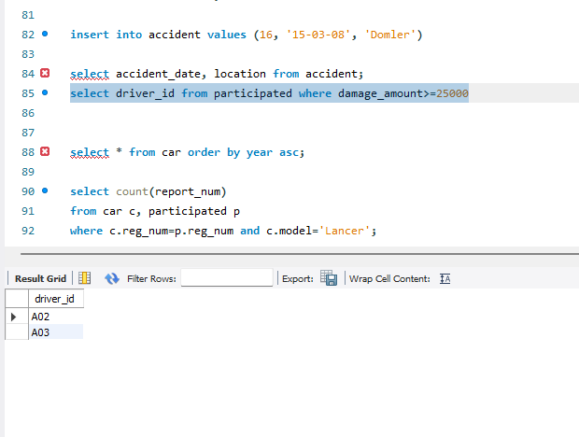

Week-2

1. Display the entire CAR relation in the ascending order of

manufacturing year.

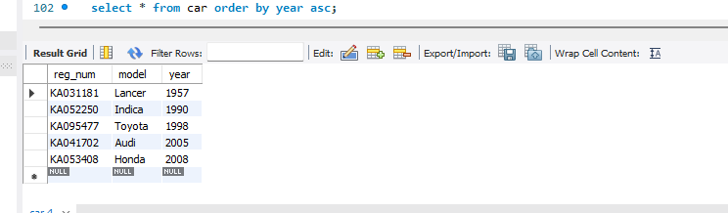

2. Find the number of accidents in which cars belonging to a specific model (example 'Lancer')

were involved.

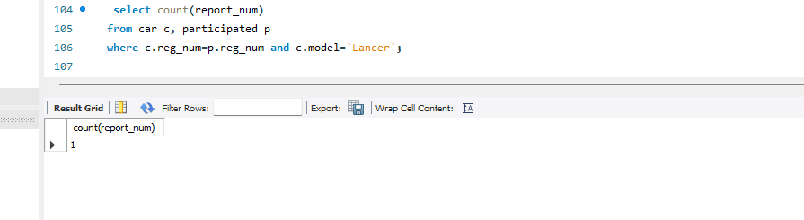

3. Find the total number of people who owned cars that were involved in accidents in 2008.

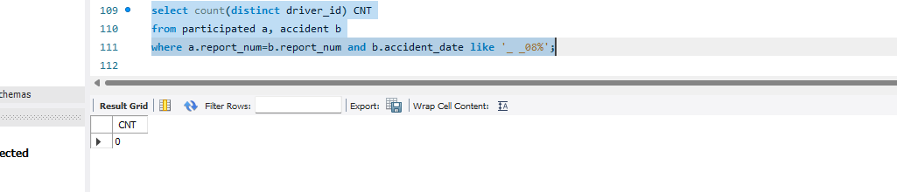

ADDITIONAL QUERIES:

1) LIST THE ENTIRE PARTICIPATED RELATION IN THE DESCENDING ORDER OF

DAMAGE AMOUNT.

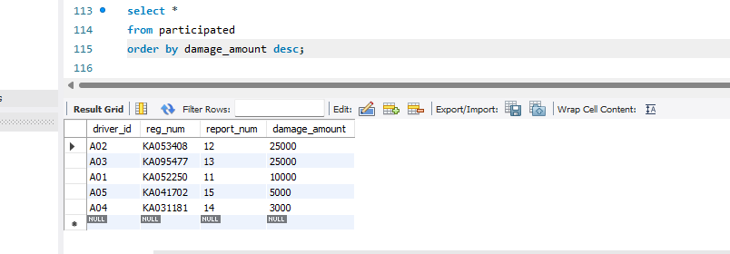

2) FIND THE AVERAGE DAMAGE AMOUNT

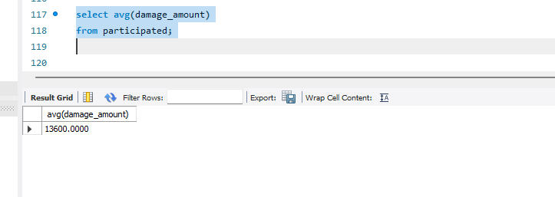

4) LIST THE NAME OF DRIVERS WHOSE DAMAGE IS GREATER THAN THE AVERAGE

DAMAGE AMOUNT.

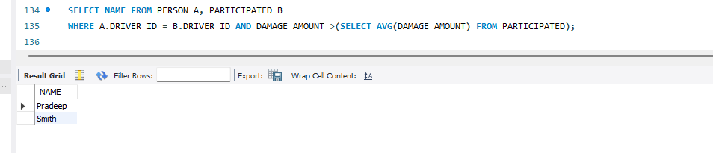

5) FIND MAXIMUM DAMAGE AMOUNT.

